**SEPTEMBER**

**Sunday, 1st**

8:00 am Praise Team Rehearsal

9:30 am Hymn Sing

10:00 amWorship Service/Communion

**Monday,2nd LABOR DAY**

Church Office Closed

**Thursday, 5th**

7:30 pm Adult Choir Rehearsal

**Saturday, 7th**

9:00 am Praise Team Rehearsal

**Sunday, 8th** OUTDOOR WORSHIP & CHURCH PICNIC

10:00 amWorship at American Legion Pavilion

Senior Youth Group

**Monday, 9th**

7:30 pm Consistory

**Wednesday, 11th**

9am-2 pm Scrappers

**Thursday, 12th**

7:30 pm Adult Choir Rehearsal

**Saturday, 14th**

9:00 am Praise Team Rehearsal

**Sunday, 15th**

8:00 am Praise Team Rehearsal

9:30 am Choir Rehearsal

10:00 amWorship Service

Sunday School begins

11:30am-noon Children’s Choir begins

12:00 NOON MILLTOWN CHURCHES PICNIC

at American Legion Pavilion

**Wednesday, 18th**

9am-2 pm Scrappers

**Saturday, 21st**

9:00 am Praise Team Rehearsal

**Sunday, 22nd**

8:00 am Praise Team Rehearsal

9:30 am Choir Rehearsal

10:00 amWorship Service

Sunday School

11:30am-noon Children’s Choir

6:00-8:00 pm Senior & Junior Youth Groups

7:30 pm Mission Trip Meeting SYG & Parents

Sanctuary

**Wednesday, 25th**

9am-2 pm Scrappers

Noon Senior Luncheon

**Thursday, 26th**

7:30 pm Adult Choir Rehearsal

**Saturday, 28th**

9:00 am Praise Team Rehearsal

**Sunday, 29th**

8:00 am Praise Team Rehearsal

9:30 am Choir Rehearsal

10:00 amWorship Service

Sunday School

11:30am-noon Children’s Choir

**UPCOMING EVENTS:**

October 13 – St. Paul’s 148th Anniversary

October 25 – Pallet Painting Party

**Please note**: the Wine & Beer Fundraiser scheduled for October 12, has been cancelled.

Jeremiah 29:11 “’For I know the plans I have for you,’ declares the Lord, ‘plans to prosper you and not to harm you, plans to give you hope and a future.”’

September is the beginning of the Church year. Ministries begin, the pews fill, and the Choir sings.

Please join us in Sunday service this month so you can meet our Pastoral candidates. Phil Kunz, our interim Pastor, will be starting on September 1st. How exciting!

Romans 12:1-2 “Therefore, I urge you, brothers and sisters, in view of God’s mercy, to offer your bodies as a living sacrifice, holy and pleasing to God – this is your true and proper worship. Do not conform to the pattern of this world, but be transformed by the renewing of your mind. Then you will be able to test and approve what God’s will is – His good, pleasing and perfect will.”

**A great big thank you to:**

Gary Conger – for electrical work

Bob Burnet – repairing porch steps

Ken Skalla – mowing

Ed Lucid – weed control

Barbara Paley – lining up contractors

**SEPTEMBER’S BENEVOLENCE**

Our September communion offering will be given to the American Legion. August communion offering will be sent to the Daisy Foundation. July’s communion offering was sent to Milltown Education Foundation.

**BREAVEMENT**

Our sympathies to the family of Gregory Reeves, who died July 6.

**2019 FINANCIALS**

JUNE YTD

Income $ 27,220.36 $124,975.14

Expense $(26,756.33) $(157,850.93)

Gain/(Loss)($ 464.03 - $(32,875.79)

JULY YTD

Income $ 13,057.04 $ 138,032.18

Expense $(21,540.65) $(179,391.58)

-$(8,483.61) **-$(41,359.40)**

“Money is not the only commodity that is fun to give. We can give time; we can give our expertise; we can give our love or simply give a smile. What does that cost? The point is, none of us can ever run out of something worthwhile to give.” – Steve Goodier

pasted-image.tiff

**PASTOR SEARCH UPDATE**

The transition team has been hard at work. Phil Kunz will start Sept. 1st as our interim pastor. Phil is a UCC pastor with interim experience, and we feel will be a help in the process. We have interviewed a number of candidates for the permanent pastor position, and have several more scheduled. At this point, there are 2 candidates we feel are worth having come to deliver a sermon and meet the congregation. Roberto Fois will be here Sept. 8th at the outdoor worship. Matt Murphy will be here Sept. 15th. Please pass the word along, this will be the congregation’s chance to hear and meet the candidates.

**CONSISTORY MINUTES**

June 10, 2019

**In Attendance:** Dave Hastings, Debbie Kovacs, Greg Reeves, Nick Bamond, Karen Gourley, Matt Park, Tracy Rucinski, Beckie Rumen, Lois Jessen, Debbie Paley, Sean Sullivan, Pastor Rich

Meeting called to order at 7:38pm by Pastor Rich who opened with a devotion from Proverbs 11:25 – “A generous man will prosper; he who refreshes others will himself be refreshed.” As Christians we ought to be willing to cheerfully share what God has blessed us with rather than hoard it for ourselves.

May’s meeting minutes were approved. Motioned by Matt P./seconded by Greg R.

**Correspondence**  
- Letter received from INC expressing gratitude for our recent offering.

**Finances**- Pastor Rich’s name has been removed from TD Bank accounts and Bank of America credit card. Still need to remove PR from authorization for investment company  
- Debbie Kovacs and Beckie Rumen will now have their names listed for credit card (not as guarantors)  
- Pastor Rich sends out Christmas and Easter letters yearly; we will need someone to take this over  
- Pastor Rich will send out Summer Appeal letter   
- Consistory will have separate meeting to determine how Pastor’s daily responsibilities will be taken over after 6/30  
- Fund Raisers:  
 - Super Bowl Pool – First Sunday in February   
 - 50/50 – Tax Day  
 - Wine & Beer Event  
 - Golf Outing – First Monday in June  
  
Financials:  
- We have a deficit of $15,723.44 for May and a YTD loss of $33,339.82. This was largely due to our insurance payments to Lloyd’s of London and Brotherhood. We should receive a credit of approximately $5400 from Lloyd’s of London and $730 from Selective. We have paid $20,061.36 for insurance so far this year but this number should go down to $14,000 after these two credits.  
- We gave $980 to Love for Brandon last month  
- We are on pace for our fundraising goals  
- Finances approved by consistory; motioned by Karen G./seconded by Tracy R.  
  
**Consistory**Communion  
- July 7 – Team 2  
- August 4 – Team 3  
- September 1 – Team 1

Communion Offering/Benevolence  
- June’s Communion Offering – Youth Group Mission Trip  
- July’s Communion Offering – VFW School Supply Drive   
- August’s Communion Offering – Milltown Education Foundation

Worship  
- We began the discussion of summer worship leaders. This discussion was continued during our transition team meeting.

**Ministry Teams**  
 *Pastor Rich laid out the yearly events/responsibilities for each of our consistory teams.*

Church & Family  
- Senior Luncheon – quarterly  
- Advent Family Night  
- Lenten Family Night  
- Christmas Caroling  
- Church Picnic (September 8)  
- 3 Church Picnic after worship (September 15)  
- Mother’s Day – Bring Your Mom to Church  
- Father’s Day – Bring Your Dad to Church  
  
Spiritual Life   
- Ash Wednesday – we host the even year (next is 2020)  
- National Day of Prayer – 1st Thursday in May  
- Community Thanksgiving Service – Sunday before Thanksgiving (2019 Methodist Church; 2020 OLOL; 2021 SPC)  
- Drama – Elana Kircher  
- Worship Computer – Rob Ramsen  
- Live Streaming – Don Wesen  
- Music/Choirs – Emily  
- Ushers/Head Ushers (confirmation class has 2nd Sunday, youth group has 4th Sunday)  
- Communion – homebound  
- Graduation Sunday  
- Holy Humor Sunday  
- Letter sign outside church  
  
Education   
- Sunday School   
 - Order curriculum  
 - Sunday school staff  
- Education classes for adults  
- Youth Group  
 - Sunday night meetings  
 - Retreat  
 - Mission Trip  
 - Fund Raisers  
 - Applebee’s (Feb for church)  
 - Duck Race (July 4 for mission trip)  
 - Santa 5K Race (Dec for mission trip)

Property  
- Snow Removal Contract  
- Lawn Care – Ken Skalla  
- Maintenance for Buildings  
- Manse  
- Service Contracts  
- Liaison to Good Day  
- Bottle Water in hallway – Home Depot  
- Recyclables – Garret Conger  
- Work Projects  
 - Front steps to parsonage need to be repaired  
 - Social Hall Door – needs painting

Office  
- Hall Rentals   
- Tidings  
- Cradle Roll  
- Bereavement Letter  
- Daily Slice  
- Prayer Concerns  
- Mail  
- Correspondence  
- 1st Time Guest Communication  
- Monthly Calendar

***Many of these events and duties will need a designated person or group responsible. This will be discussed at a future meeting once Pastor Rich completes his list for consistory.***

Future Dates  
- Consistory – June 24  
  
Consistory meeting adjourned at 8:49pm, Pastor Rich closed the meeting with Prayer Concerns and the Lord’s Prayer. Motioned by Karen G./seconded by Nick B.

The remainder of our time together was spent discussing the progress of our pastoral search, summer worship, and cleaning of the sanctuary.



**FELLOWSHIP HOUR**

HOSTS NEEDED:

You are responsible for providing treats, juice for the children and milk for coffee.

Coffee, cups, plates, napkins, plastic utensils and sweeteners are provided.

SIGN UP TO HOST

@ coffee hour or contact:

Julie Park 732-545-4266

[mj1park@optonline.net](mailto:mj1park@optonline.net) or

Tracy Rucinski 732-545-6982

[traysee7413@yahoo.com](mailto:traysee7413@yahoo.com).

HEAD USHERS FOR

September

1 Team #3

8 Karen Gourley Picnic

15 Fran Christ

22 Nick Bamond

29 Debbie Kovacs

## MEMORIAL FUND

HARRY L. HUBBS & ELIZABETH HUBBS

Irma Lou Hubbs

VERA BAIER

Ethel Varinez

GREGORY REEVES

Chuck & Tracy Rucinski

Peter Herral

Margaret Schmidt

Marjorie Conger

Rita Migliore

Grace Kothari

LOUISE HIPKO

Charles & Beverly Rucinski

MUSIC FUND

HELEN SOULEA

Doris Weber

GENERAL FUND

Lynn Junker Simms

OFFSET LENTEN DINNERS

Bev Christensen

PASTOR RICH

Rose Kobezak

GREGORY REEVES

Ken & Judy Skalla

Altar Candles in memory of Victor Karren, M.D.

Ruth Karren

ARIELLA HOPKINS DAY

Sons of the American Legion

SCHOLARSHIP FUND

HELEN SOULEA

Van Liew Cemetery Assoc.

GREGORY REEVES

Debbie Cheeseman

Karen Gourley

Memory of RAY CONGER’S BIRTHDAY 9/14

Marjorie Conger & Family

SYG MISSION TRIP

VAN RENTAL

WILLIAM & Lila Bernstein

KEN JUNKER BIBLE FUND

Lynn Junker Simms

WINDOWS

VERA BAIER

Jane Osman

GREGORY REEVES

Ray Hippeli & Family

Jane Osman

Arlene Mowery

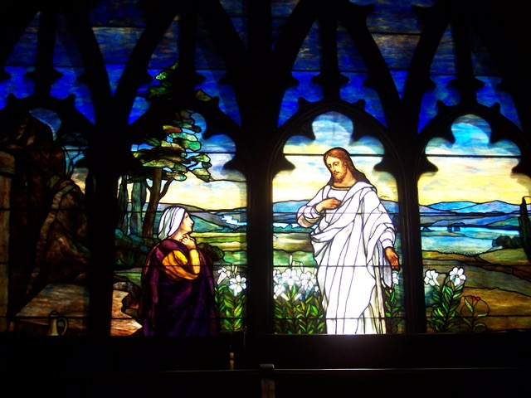

Photo Book of St. Paul’s Church Windows is available through Shutterfly. <https://link.shutterfly.com/e/wZt0WgHqTX>

This is not a fundraiser but something you may want to purchase as gifts or for yourself to enjoy

**SCRAP BOOKING**

Do you have photos you don’t know what to do with Join our Scrapbooking/Crafting Club. We meet two Wednesdays a month in the social hall from 10am – 2 pm, $5.00, bring your lunch. Call Donna Lucid to RSVP or with any questions at 908-331-1758.

***LETTERS….***

## Dear St. Paul’s Church,

*Thank you so much for everything, your support of me through my college journey means the world to me. Whether through scholarships, or even holiday care packages, I know you are always thinking about me. Thank you.*

*God be with you,*

*Sean Wesen*

*Thank you for awarding me the St. Paul’s scholarship this year. It will be very helpful as I begin my college journey! I hope to follow God’s plan as I start this new chapter and I will use this award to do so.*

*Thanks again,*

*Marisa Keiser*

*Dear Pastor Rich and Congregation,*

*Thank you so much for the incredibly generous donation to our little warrior Landon! Words can’t describe our gratitude. It’s truly an amazing gesture. The money raised will go towards equipment and therapies to help Landon thrive in today’s world.*

*With much love,*

*Landon, Lauren & Bob Hartz*

*We hope our donation from“Ariella Hopkins Day” each year helps you. It’s 4 years without Ariella and the tears never end! We celebrate her life and legacy in the middle of town each May, and by helping others we feel that we keep “Ariella’s Smile Alive”!*

*Love Bobby, Lisa, Ariella & Emily*

## C:\Users\Carol\AppData\Local\Microsoft\Windows\INetCache\IE\B83SEAFA\children-and-youth[1].png

## SUNDAY SCHOOL

Starts SEPTEMBER 15

## Sunday school is for children ages 3 years old through 6th grade.

Sunday school begins with worship at 10am in the sanctuary. The children are dismissed to their classes after the junior sermon.

Registration forms need to be completed and returned to Church Office or Sunday School Teacher by September 15.

**COLLEGE STUDENTS**

Once you are settled into your dorm/apartment, take a moment and let us know your new address. We will be sending you encouragement and prayers through the school year. [stpaulschurch@optonline.net](mailto:stpaulschurch@optonline.net)

## Music at St. Paul’s

**What a summer!**

Since Pastor Rich retired on June 30, our summer services have been led by an abundance of volunteers. Thanks be to God for all who have preached, read, prayed, served communion, sung, or otherwise shared their leadership!

At our special June 30 service, we had 35 musicians involved in the service. Thanks be to God for them and for all present, who brought such a spirit of thankfulness and love.

Thanks be to God for our praise band, which represented St. Paul’s in the Milltown 4th of July parade, and played extra music for Youth Sunday and while the music director was on vacation! We are already gearing up to play at our Sept. 8 picnic.

Truly the last few months have been an example of good stewardship of our gifts together.

**Summer Hymn Sing**

Our last hymn sing of the summer will be on Sun., Sept. 1, at 9:30 am in the sanctuary. Come join us and sing some favorites before our 10 am service!

**Choirs resume regular schedules**

Adult Choir resumes Thurs. rehearsals on Sept. 5, 7:30 – 9 pm. New singers are welcome to join us!

Children’s Choir resumes on Sept. 15, 11:30 – noon in the chapel of the church school building. We rehearse every Sunday and sing about once a month. New singers in grades 1-6 are welcome to join us!

**Have a question or comment about our music ministry?** Want to get involved?

Contact Emily at esensenb@hotmail.com



**MARK YOUR CALENDARS**

**Due to popular demand we will be sponsoring another**

**St. Paul’s Church Pallet Painting**

**Fundraiser**

**Friday, October 25th**

**7:00 pm**

**Stay tuned for more information**

**Any questions please see**

**Debbie Cheeseman or Nikki Wesen**

**SENIOR YOUTH GROUP**

We are going to kick off Senior Youth group on the 8th with a 4 Square tournament (we’ll use real rules, not the ones the kids were trying to teach us on the mission trip)!



It will start after our Outdoor Worship and Picnic. Worship is at 10am. Picnic starts at 11:15AM, see you all there!

Our first Sunday night meeting will be September 22nd @ 6PM (including a 2020 Mission Trip meeting, see below!)

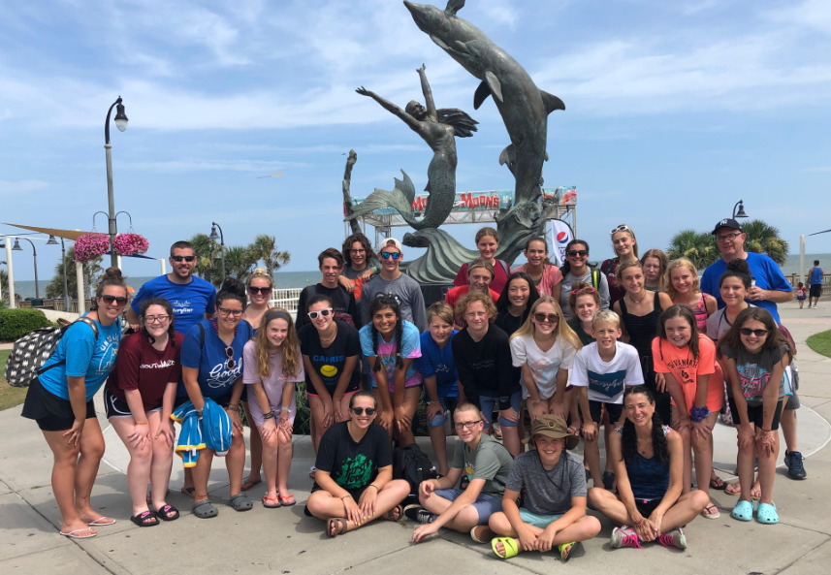

**MISSION TRIP 2020**

There will be a meeting, in the sanctuary on Sept. 22rd at 7:30 pm, for all youth interested in participating in our mission trip set for July 12 - 17, 2020. The destination is Rutland, Vermont!

It is essential that parents attend this meeting. We will be discussing fundraising events and the calendar for the year. Each youth will be required to return the registration form along with a $150.00 non-refundable, deposit by November 1st.

**JUNIOR YOUTH GROUP**

It’s time for another exciting year of JYG. All 4th-6th graders are welcome – Bring a friend! (does Not have to be a member of St. Paul’s)

Introduction/orientation meeting that will give parents/kids an opportunity to learn a little more about what the Junior Youth Group is all about - Sunday, September 22nd, 6-8 pm in the Social Hall.

Any questions, please call Sean Sullivan at 732-565-3669.

**FISH HOSPITALITY PROGRAM**

Our Education Building will be used by FISH Hospitality the week of November 17th through the 24th.

YOUR help is needed to:

Unload the beds & set-up rooms (Sunday after worship)

Provide a dinner meal (all nights)

Transport residents to the shower (all weeknights)

Sleep over one night (all nights, one male and one female volunteer needed!)

Please reach out to either:

Dawn Ramsen

732-492-9976

r4withjoy@yahoo.com

Jeff Rumen

732-407-4326

jrumen@msn.com

**CHURCH ETIQUETTE**

Use the list below in all churches and during any religious ceremony

(weddings, baptisms, worship service, etc.) You will never again have to wonder if you’re doing the right thing at the right time. The secrets listed below will guarantee you a successful church visit.

. Dispose of gum, snacks, food and

drinks before entering the church.

. Dress modestly and with respect.

Remove your hat when entering the church.

. Follow the worship service or ceremony with the bulletin/missalette provided.

. Stand, sit or kneel when appropriate.

. Show respect – do not talk, fool

around, push, shove, etc. in church. Walk quietly.

. Turn cell phone off.

. Respect the church furnishings.

. PARTICIPATE. Imagine going to a

sports event and the crowd didn’t cheer or yell or boo. The excitement of being there, the whole point of going, would be lost. Don’t sit on the sideline, get into the spirit – read the Gospel, say the prayers and sing with the congregation!



**JOIN US ON SUNDAY, SEPTEMBER 8TH AT OUR ANNUAL OUTDOOR WORSHIP AND PICNIC** at the American Legion Pavilion in Milltown. There will be fellowship, games, music and above all great food! The Men’s Group will provide the hamburgers, hot dogs, rolls, etc. We ask those of you attending to please bring a side dish and/or a dessert. All of your contributions the past years have been outstanding!! The service will be performed by one of our Pastor candidates Rev. Roberto Fois. Please sign up for a committee. I really need your help. Questions, please contact Karen Gourley at 732-672-9702 or [kgourley@optonline.net](mailto:kgourley@optonline.net).



**SCHOOL SUPPLIES –** We are collecting school supplies for the local Milltown schools. Please bring items to the church office or leave in the Narthex. Last year we did an outstanding job – let’s do it again!



**MILLTOWN CHURCHES’ PICNIC**

The Churches in Milltown are getting together this year for the kick-off to the year picnic! We will be gathering at the American Legion Pavilion on September 15 at noon to celebrate a new year of ministry together!

Please sign up so we know how many to expect and bring your favorite side dish or dessert for everyone to try! Sign up by calling our church office 732-828-0020.

Join in with all of your friends from other Churches as we all have good fellowship together!

**CALLING ALL “SENIORS"**

**Our next Senior Luncheon is scheduled for**

**Wednesday, September 25th**

**12:00 noon**

**Come join us for an afternoon of food, friendly faces,**

**conversation and fun.**

**We will need a head count, so if you can join us,**

**please call the church office**

**(732-828-0020)**

**or sign up in the church narthex/in the**

**social hall during coffee hour.**

**Looking forward to seeing you!**

ST. PAUL’S CHURCH

Founded in 1872

So. Main St. & W. Lakewood Ave.

Pastor Phil Kunz, Interim Pastor

Rev. Richard H. Weyer, Pastor Emeritus

Emily Sensenbach-Gopal,

Director of Music

Church Office 732 828-0020

FAX # 732 828-0027

stpaulschurch@optonline.net

www.stpaulsmilltownnj.org

Please leave a message if no one is available.

Church Secretary Mrs. Carol Lagowski

Office hours: 9:00 a.m.-1:00 p.m.

Financial Secretary Mrs. Debbie Paley

(address inquiries to church office)

Please address all financial inquiries to the Church Office.

**2019 CONSISTORY**

Elders:

Melanie Dwyer

Karen Gourley

David Hasting

Lois Jessen

Matt Park

Nikki Wesen

Deacons:

Nicholas Bamond

John Garback

Debbie Kovacs

Tracy Rucinski

Beckie Rumen

Sean Sullivan

********************************

Save time and prevent mistakes by writing your parishioner number on your checks and envelopes. Example: 002W

********************************

Please notify the church office if any of the following changes occur in your household: address change, phone number change, email change, marriage, separation/divorce, death, birth, adoption, adult child(ren) moving out, or a family member being moved to a rehab. or nursing home.

We would like to keep our membership list up-to-date, but we need YOUR cooperation to do so!

ST. PAUL’S CHURCH

62 South Main Street

Milltown, NJ 08850

(732) 828-0020

**SEPTEMBER, 2019**

ADDRESS SERVICE REQUESTED

DATES TO REMEMBER:

Sept. 1 - Communion

Sept. 8 – Outdoor Worship & Church Picnic

Sept. 9 – Consistory

Sept. 15 – Milltown Churches’ Picnic

Sept. 8 & 22 – Senior Youth Group

Sept. 22 – Junior Youth Group

Sept. 4 & 18 – Scrappers

**TIDINGS**

**Worship Service 10:00 a.m.**

**Sunday School 10:00 a.m.**

**DATED MATERIAL**

August 21, 2019

